

VISVESVARAYA TECHNOLOGICAL UNIVERSITY
JNANA SANGAMA, BELAGAVI-590018, KARNATAKA

Project Report on
“Supply Chain Management of Food Items in Cold Storage Using IOT”

Submitted impartial fulfillment of the requirements for the VII semester
Bachelor of Engineering
In
Electronics and Communication Engineering
Of
Visvesvaraya Technological University, Belagavi By
HITHA M 1AJ22EC019
NISARGA M PATIL 1AJ22EC034
SANJANA R 1AJ22EC043
VARSHA RM 1AJ22EC053
Under the Guidance of
TANUJA G
Assistant Professor

Department of Electronics and Communication Engineering CAMBRIDGE INSTITUTE OF TECHNOLOGY NORTH CAMPUS BANGALORE-562110
2025-2026

CAMBRIDGE INSTITUTE OF TECHNOLOGY NORTH CAMPUS
Bangalore-562110
DEPARTMENT OF ELECTRONICS AND COMMUNICATION ENGINEERING

CERTIFICATE

Certified that the project work entitled “SUPPLY CHAIN MANAGEMENT OF FOOD ITEMS IN COLD STORAGE USING IOT” was carried out by HITHA M, NISARGA M PATIL, SANJANA R, VARSHA RM USN:- 1AJ22EC019, 1AJ22EC034, 1AJ22EC043, 1AJ22EC053 a Bonafide Student of Cambridge Institute Of Technology North Campus in partial fulfillment for the award of Bachelor of Engineering / Bachelor of Technology in Electronics And Communication Engineering of the Visvesvaraya Technological University, Belgaum during the year 2025-2026. It is certified that all corrections/suggestions indicated for the Internal Assessment have been incorporated in the Report deposited in the departmental library. The project report has been approved as it satisfies the academic requirements in respect of Project work prescribed for the said Degree.

-----------------------------
Project Guide
TANUJA G
Assistant Professor Cambridge Institute of Technology, North Campus
---------------------------------------
Head of The Department
Dr. TEJASWINI C
Professor & HOD Cambridge Institute of Technology,
North Campus
-----------------------------------------------
Principal
Dr. PRASAD NAIK HAMSAVATH
Cambridge Institute of Technology, North Campus


External Viva
Name of The Examiners Signature with Date
1
2

DECLARATION

We by HITHA M, NISARGA M PATIL, SANJANA R, VARSHA RM, bearing the USNs:–
1AJ22EC019, 1AJ22EC034, 1AJ22EC043, 1AJ22EC053 are students of the VII semester, Electronics and Communication Engineering, Cambridge Institute of Technology, hereby declare that the project entitled “SUPPLY CHAIN MANAGEMENT OF FOOD ITEMS IN COLD STORAGE USING IOT” has been carried out by us and submitted in partial fulfillment of the course requirements for the Bachelor of Engineering in Electronics and Communication Engineering as prescribed by Visvesvaraya Technological University, Belagavi, during the academic year 2025-2026.
We also declare that, to the best of our knowledge and belief, the work reported here does not form part of any other report on the basis of which a degree or award was conferred on an earlier occasion by any other student.

Date:08/01/2026 Place: Bangalore
Names USN Signature
HITHA M 1AJ22EC019

NISARGA M PATIL 1AJ22EC034
SANJANA R 1AJ22EC043

VARSHA RM 1AJ22EC053

ACKNOWLEDGEMENT

We would like to place on record my deep sense of gratitude to the Management, Cambridge Institute of Technology North Campus, India, for providing excellent infrastructure and an academic environment at CITNC, without which this work would not have been possible.
We am extremely thankful to Dr. Prasad Naik Hamsavath, Principal Cambridge Institute of Technology North Campus, for providing me with an academic ambience and laboratory facilities, as well as for his everlasting motivation to carry out this work and shape our careers.

We express my sincere gratitude to Dr. Tejaswini C, Head of the Department, Department of Electronics and Communication Engineering, Cambridge Institute of Technology North Campus, for her stimulating guidance, continuous encouragement, and motivation throughout the course of this work.

We also wish to extend my thanks to my Guide Tanuja G, Assistant Professor, Department of Electronics and Communication Engineering, Cambridge Institute of Technology North Campus, for her critical, insightful comments, guidance, constructive suggestions, and support to improve the quality of this project work.
We would like to thank all the faculty members and non-teaching staff of the Department of Electronics and Communication Engineering for their constant support. I also extend my heartfelt gratitude to my parents and friends for their constant moral and financial support.

ABSTRACT

The supply chain of perishable food items requires continuous monitoring to maintain quality and reduce spoilage. This project presents an IoT-based Cold Storage Supply Chain Management system designed to track and control critical parameters such as temperature, humidity, and door activity within cold storage units. Using sensors connected to an ESP32 microcontroller, real-time data is collected and transmitted to a cloud platform, enabling remote monitoring through a web or mobile application. Alerts are generated automatically when environmental conditions exceed safe limits, helping prevent food deterioration. The system improves transparency, reduces wastage, and enhances the overall efficiency of the cold-chain logistics. This IoT solution offers a cost-effective and reliable method to ensure safe storage and timely delivery of food items.
Efficient supply chain management of perishable food items requires continuous monitoring of storage conditions to maintain freshness, reduce wastage, and ensure consumer safety. Traditional cold-storage systems often lack real-time visibility, resulting in undetected temperature fluctuations and product deterioration. This project presents an IoT-based Cold Storage Supply Chain Management system designed to overcome these limitations through automated environmental monitoring and data analytics.

The system employs sensors such as temperature, humidity, and gas detectors, which are interfacedwith an ESP32 microcontroller. These sensors continuously collect data from the cold-storage environment and transmit it to a cloud platform via Wi-Fi. The cloud dashboard provides real-time visualization of all parameters, historical data analysis, and downloadable reports. Additionally, the system incorporates alert mechanisms that notify the user instantly through SMS or app notifications when any parameter crosses the safe threshold, enabling immediate corrective action.

By providing continuous monitoring, traceability, and proactive alerts, this IoT solution ensures that food products are stored under optimal conditions throughout the supply chain. The proposed system significantly reduces spoilage, minimizes economic losses, enhances operational efficiency, and supports better decision-making for cold-chain logistics. Overall, the project demonstrates a smart, reliable, and cost-effective approach to modernizing cold-storage management using IoT technology.

TABLE OF CONTENTS

CHAPTER | TOPIC | PG NO.
 | CERTIFICATE | I
 | DECLARATION | II
 | ACKNOWLEDGEMENT | III
 | ABSTRACT | IV
 | TABLE OF CONTENTS | V
 | LIST OF FIGURES | VI
 | LIST OF TABLES | VII
1. | INTRODUCTION | 1
1.1 | Objectives | 2
1.2 | Aim Of the Project | 2
1.3 | Problem Statement | 2
2. | LITERATURE REVIEW | 3-8
3. | SYSTEM DESIGN AND METHODOLOGY | 9-25
3.1 | System Architecture Overview | 9
3.2 | Block Diagram Description | 10-18
3.3 | Mechanical Design Description | 19
3.4 | Software Design | 20-22
3.5 | Data Flow Description | 23-25
4. | RESULTS AND ANALYSIS | 26-29
4.1 | Sensor Data Acquisition | 26-27
4.2 | Data Processing and Decision Making | 27
4.3 | Wireless Communication using IoT | 28
4.4 | SMS Alerts via GSM | 29
4.5 | GPS Location Tracking | 29
5 | CONCLUSION AND FUTURE WORK | 30-31
6 | REFERENCES | 32

LIST OF FIGURES

SL NO. | FIGURE NAME | PG NO.
1. | Block diagram | 10
2. | ESP32 | 12
3. | DHT11 Temperature and Humidity | 12
4. | MQ135 Gas Sensor | 13
5. | LDR | 14
6. | Analog Moisture Sensor | 14
7. | GPS Module | 15
8. | GSM Module | 16
9. | Relay Module | 16
10. | IoT Communication Layer | 17
11. | Lithium Ion Battery | 18
12. | Arduino IDE Software | 20
13. | Blynk IoT Platform | 21
14. | Flow chart | 23-24
15. | Supply Chain Management of Food Items in Cold Storage Using IoT | 26
16. | Blynk Status | 28

CHAPTER 1

INTRODUCTION

The rapid growth of the food industry and the increasing demand for safe, high-quality, and fresh food products have made efficient supply chain management an essential requirement in modern society. Perishable food items such as fruits, vegetables, dairy products, meat, and frozen goods require strict environmental control during storage and transportation to maintain their freshness and nutritional value. Even minor variations in temperature or humidity can lead to spoilage, microbial growth, and reduction in product shelf life. As a result, cold storage systems and cold-chain logistics play a critical role in ensuring that food products reach consumers in safe and consumable conditions.
However, traditional cold-storage management often faces several limitations. Many systems rely on manual monitoring, periodic checks, or outdated equipment, which makes it difficult to detect sudden changes in storage conditions. Inconsistent monitoring, human error, and lack of real-time visibility contribute significantly to wastage, increased operational cost, and reduced efficiency across the supply chain. According to industry reports, almost one-third of the total food produced globally is wasted, with a large portion occurring due to improper handling and inadequate cold-storage monitoring. In countries with developing supply-chain infrastructure, the percentage of food wastage is even higher, emphasizing the urgent need for modern, technology-driven solutions.
This project, titled "Supply Chain Management of Food Items in Cold Storage Using IoT", focuses on designing a smart, automated, and reliable system for monitoring critical environmental parameters such as temperature, humidity, and gas levels inside cold-storage units. By using an ESP32 microcontroller and a combination of sensors, the system collects real-time data and transmits it wirelessly to a cloud server. Through a dashboard or mobile application, users can monitor the status of food storage conditions from anywhere. Instant alerts are generated when any parameter crosses the permissible limit, enabling quick decision-making and preventing food spoilage.
In conclusion, the adoption of IoT in cold-storage supply-chain management represents a major step toward improving food safety, quality, and sustainability. This project not only highlights the technological advancements possible through IoT but also provides practical solutions that can help reduce food wastage and enhance the efficiency of the entire supply-chain ecosystem.

OBJECTIVES

- To continuously monitor critical environmental parameters such as temperature, humidity, and gas concentration inside the cold storage using appropriate sensors.

- To design an IoT-based architecture that enables real-time data collection and wireless transmission of sensor data to a cloud or remote monitoring platform.
- To provide real-time alerts and notifications in case of abnormal storage conditions or equipment failure.

- To reduce food spoilage and post-harvest losses by maintaining optimal storage conditions throughout the supply chain.

- To improve transparency and traceability in the cold storage supply chain by enabling remote access to storage condition data.

AIM OF THE PROJECT
The main aim of this project is to design and implement an IoT-based system for efficient supply chain management of food items in cold storage. This project focuses on continuously monitoring critical environmental parameters such as temperature and humidity using IoT sensors to ensure proper storage conditions for perishable food products. By integrating sensors, microcontrollers, and cloud technology, the system helps in reducing food spoilage, minimizing wastage, and maintaining food quality throughout the supply chain. The project also aims to provide real-time data access and alert notifications to storage operators and stakeholders in case of abnormal conditions. Overall, the goal is to improve food safety, traceability, and operational efficiency in cold storage supply chain management using IoT technology.

PROBLEM STATEMENT

Lack of real-time monitoring of temperature and humidity in cold storage leads to spoilage of perishable food items.

Manual inspection and control of cold storage conditions is time-consuming and prone to human errors.

Unexpected temperature fluctuations or power failures are not detected immediately, causing quality degradation of food products.

High food wastage and economic loss occur due to inefficient cold storage management and lack of smart monitoring systems.

CHAPTER 2

LITERATURE REVIEW

- The Internet of Things (IoT) is a new evolution in technological advancement taking place in the world today. This paradigm allows physical world objects in our surroundings to be connected to the Internet. This idea comes to life by utilizing two architecture; the Sensing Entity in the environment that collects data and connects itself to the cloud and the Cloud Service that hosts the data from the environment and controls the parameters. The combination of wireless sensor networks and cloud computing is becoming a popular strategy for the IoT era. The cold chain requires controlled environment for sensitive products in order for them to be fit for use. The monitoring process is the first assurance which tells if a certain process has been carried out successfully and the controlling mechanism is performed by the Relays. Taking advantage of IoT and its benefits to monitor and control the cold chain logistics will result in better management and product handling. This paper looks at a system comprising of MCU wireless sensor network and server which can be an ideal system to monitor temperature and humidity of cold chain logistics and control them to required values.
- Storage and refrigerated transport, effectively keep food appearance, Colourand Lustre, nutrients and flavor substances, achieve quality fresh food, the purpose of to prolong food storage time. But, the food cold chain logistics in China and abroad than there are many shortage, how to quickly and efficiently enhance the level of food cold chain logistics is imminent. lot technology known as the third wave of world information industry[1], its technology widely used, how it can be applied to the field of food cold chain, has become the focus of experts and scholars. Based on the food cold chain transportation, the problems of food cold chain logistics in our country is expounded.
- Li Zhang and Wenhao Liu (2023) conducted an in-depth study on an IoT-enabled cold chain monitoring system designed to manage temperature and humidity levels of perishable food items. Their research mainly focuses on real-time data collection using environmental sensors connected to cloud platforms. The system continuously monitors storage conditions and transmits data to a centralized cloud server, where it can be accessed by supply chain

stakeholders. One of the key features of their system is the alert mechanism, which notifies users immediately when temperature or humidity exceeds safe limits. This timely alert helps prevent food spoilage and quality degradation. The authors emphasize that the use of IoT technology improves transparency across the cold storage supply chain by allowing real-time tracking and historical data analysis. Their study also highlights improved coordination between storage operators, transporters, and distributors. However, the system depends heavily on stable internet connectivity, which may limit its performance in remote locations. Overall, the authors conclude that IoT-based cold chain monitoring significantly enhances operational efficiency, reduces food wastage, and ensures food safety. Their work demonstrates the importance of integrating sensor technology and cloud computing to modernize cold storage supply chain management.
- Deepika R. and Harish Kumar (2023) proposed a smart cold storage system using Internet of Things technology combined with cloud integration. Their research focuses on maintaining food quality during storage and transportation by continuously monitoring temperature and humidity conditions. The system uses IoT sensors installed in cold storage units to collect environmental data, which is then transmitted to cloud servers for storage and analysis. This enables real-time monitoring and remote access to data by operators and supply chain managers. The authors highlight that continuous monitoring helps detect abnormal conditions early, allowing timely corrective actions. Their system also supports data visualization and analysis, which aids in decision-making and planning. The results of their study show a significant improvement in the shelf life of perishable food items due to better control of storage conditions. However, they mention challenges related to data security and dependency on cloud infrastructure. Despite these limitations, their research proves that IoT and cloud-based solutions are effective in reducing food spoilage and improving efficiency in cold storage supply chains. Their work supports the adoption of smart technologies for modern food logistics management.

- S. Prakash and R. Senthil (2022) studied the application of IoT sensors in monitoring cold storage conditions for fruits and vegetables. Their research emphasizes the importance of automation and reduced human intervention in cold storage systems. The proposed system uses temperature and humidity sensors to continuously monitor storage environments and transmit data to a remote monitoring platform. This allows farmers, suppliers, and warehouse managers to track food conditions from any location. The authors highlight that remote monitoring improves supply chain reliability and helps prevent losses caused by delayed detection of temperature fluctuations. The system also reduces labor costs and minimizes human errors associated with manual monitoring. Their research shows that automated IoT systems improve the shelf life and quality of agricultural produce. However, they point out that the initial setup cost and technical complexity may be challenging for small-scale farmers. Despite these challenges, the study demonstrates the effectiveness of IoT technology in improving cold storage management. The authors conclude that IoT-based monitoring systems are essential for ensuring food quality and strengthening agricultural supply chains.
- 4. A. Kumar and P. Singh (2022) developed an IoT-based cold chain management model that integrates RFID technology with temperature sensors. Their research aims to improve traceability of perishable food items from farm to consumer. RFID tags are used to uniquely identify food products, while IoT sensors continuously monitor environmental conditions during storage and transportation. The collected data helps track temperature variations at different stages of the supply chain. The authors highlight that this integration improves visibility and accountability in food logistics. Their study shows that combining RFID with IoT technology significantly reduces losses caused by improper handling and temperature abuse. The system also helps identify the exact point in the supply chain where quality degradation occurs. However, the authors mention increased system cost and complexity as limitations. Despite these drawbacks, the research demonstrates that RFID-enabled IoT systems play a crucial role in improving food safety and traceability. Their work contributes to developing smarter and more transparent cold chain supply systems.

[7] D. R. Lim, Ryoo, and Gwark Chang (2021) proposed a remote monitoring system for cold storage using serial communication techniques. The main objective of their research was to monitor temperature conditions inside cold storage units from a remote location. The system uses sensors to measure temperature values and transmits the data through serial communication to a monitoring station. This approach reduces the need for manual inspection and helps in maintaining required storage conditions for perishable food items. Their system is useful for small-scale cold storage units where basic monitoring is sufficient. However, the authors also mention limitations in scalability, as serial communication is not suitable for monitoring multiple storage locations simultaneously. Additionally, the system faces challenges in long-distance communication and flexibility. Despite these limitations, the study highlights the importance of remote temperature monitoring in reducing food spoilage and improving cold storage management. This work laid the foundation for advanced IoT-based cold storage monitoring systems by demonstrating the need for automated and remote supervision of storage conditions.
[8] Amrita Srivastava and Ankita (2021) presented an IoT framework for a smart food monitoring system with a focus on analyzing food losses caused by improper cold storage. Their research highlights how lack of proper monitoring leads to significant wastage of perishable food items. The proposed system uses IoT sensors to collect environmental data such as temperature and humidity and analyzes this data to provide statistical information on food loss. The framework helps stakeholders understand the impact of cold storage failures on food quality and supply chain efficiency. However, the authors identified a major limitation in their work: the absence of an alert mechanism. Without real-time alerts, users may not respond quickly to abnormal conditions, which can still result in food damage. Despite this limitation, the study provides valuable insights into the role of IoT in understanding and reducing food wastage. Their work highlights the need for combining monitoring systems with alert and control mechanisms to achieve effective cold storage management.
[9] Maria Gonzalez and Juan Perez (2021) studied smart cold chain systems using IoT and data analytics techniques. Their research focuses on detecting temperature variations and predicting spoilage risks in perishable food items. The system collects sensor data

continuously and applies data analytics to identify patterns and trends. Predictive models are used to estimate spoilage risks and optimize inventory planning. The authors highlight that early prediction of spoilage helps reduce food waste and improves supply chain efficiency. Their study also emphasizes better resource utilization and improved decision-making through data-driven insights. However, they mention that advanced analytics require skilled personnel and computational resources. Despite these challenges, the research demonstrates the strong potential of combining IoT with data analytics in cold storage management. The authors conclude that predictive monitoring systems significantly enhance food quality control and reduce economic losses in the supply chain.
[10] R. Karthikeyan and S. Balaji (2021) focused on IoT-based warehouse monitoring systems for frozen food storage. Their research addresses critical issues such as temperature fluctuations and power failures that can affect food quality. The authors designed an alert-based system that immediately notifies operators when abnormal conditions occur. Sensors continuously monitor storage parameters and send alerts through communication networks. This rapid response mechanism helps prevent spoilage and ensures food safety. Their findings show reduced operational risks and improved reliability of cold storage facilities. However, the system depends on sensor accuracy and network availability. Overall, their study highlights the importance of alert systems in improving cold storage safety and operational efficiency.
[11] Anitha S. and Mahesh B. (2020) proposed a GSM-based IoT cold storage monitoring system suitable for remote areas with limited internet access. Their system uses temperature sensors and GSM modules to send SMS alerts to users when storage conditions exceed safe limits. This approach ensures continuous monitoring even in rural locations. The authors highlight that SMS-based alerts are reliable and cost-effective. However, the system offers limited data visualization compared to cloud-based platforms. Despite this limitation, their research demonstrates a practical solution for cold storage monitoring in connectivity-challenged areas.
[12] John Miller and David Brown (2020) explored cloud-based IoT solutions for cold supply chains. Their study emphasizes centralized data storage, real-time reporting, and improved coordination among supply chain stakeholders. Cloud platforms enable seamless data .

CHAPTER 3

METHODOLOGY

SYSTEM DESIGN
The methodology defines the systematic approach used to design, develop, and implement the Cold Chain IoT Monitoring System with SMS Alert and GPS Tracking. This project follows an engineering design methodology that includes requirement analysis, hardware selection, system integration, programming, and testing. The steps adopted ensure that the final system is reliable, scalable, and suitable for practical cold chain monitoring applications.

System Architecture Overview

Sensing Layer - Temperature, humidity, and other environmental sensors are installed inside cold storage units and transport containers to continuously monitor food storage conditions.
Data Acquisition Unit - A microcontroller or embedded system (such as Arduino) collect data from sensors and converts it into a digital format for processing.
Processing Layer - The collected sensor data is processed locally to check for abnormal conditions such as temperature rise or humidity variation.
Communication Layer - Data is transmitted to remote servers using communication technologies like Wi-Fi, GSM or Bluetooth depending on network availability.
Analytics & Alert System - Cloud-based analytics tools analyze the data and generate alerts if storage conditions exceed safe limits.
Application Layer - Web or mobile applications display real-time data, historical reports, and alert notifications to users.
Control Mechanism - Automated control systems can adjust refrigeration or ventilation to maintain optimal storage conditions.

3.2 Block Diagram Description

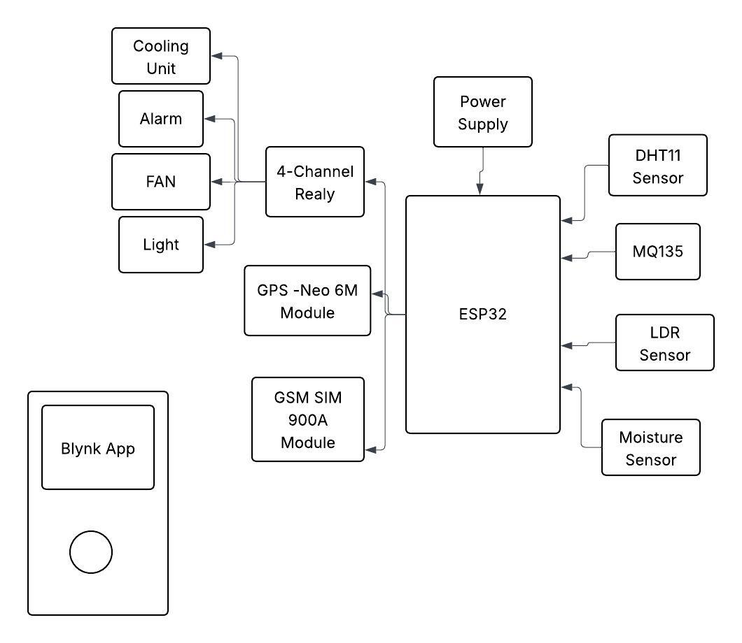

Fig 3.2: Block Diagram

The IoT-based cold storage supply chain management system is designed to monitor and maintain optimal environmental conditions for perishable food items such as fruits, vegetables, dairy, and meat. At the heart of the system is the ESP32 microcontroller, which acts as the central processing unit. It receives input from various sensors, processes the data, and sends control signals to connected devices to maintain ideal storage conditions. Sensors such as the DHT11 measure temperature and humidity and the moisture sensor detects water or high humidity. The system is powered by a regulated power supply, ensuring continuous operation, and the ESP32 communicates with the relay module, which controls high-power devices like the cooling unit, fan, alarm, and light. The cooling unit maintains low temperatures, the fan ensures uniform air circulation, the alarm alerts operators to abnormal conditions, and the light is controlled based on need or security requirements.
The GSM module enables the system to send instant SMS notifications to warehouse operators or supply chain managers whenever storage conditions exceed safe thresholds, such as a sudden rise in temperature, high humidity, or gas detection. This feature is especially useful in remote storage facilities or during transportation, where on-site supervision may not be feasible. The GPS module allows the tracking of mobile storage units, such as refrigerated trucks, ensuring that environmental conditions are maintained throughout the supply chain. In addition to SMS-based alerts, the system is integrated with the Blynk mobile application, which provides a real-time dashboard for monitoring sensor data, viewing historical trends, and receiving notifications. The overall architecture of the IoT-based cold storage system provides multiple advantages for modern supply chain management. Continuous monitoring of temperature, humidity, moisture, and gas ensures that perishable food items remain fresh and safe for consumption. Automation reduces the dependency on manual checks, minimizing human errors and labor costs. GPS integration ensures the traceability of mobile storage units, enhancing accountability and supply chain transparency. In summary, this IoT-based cold storage architecture combines sensing, control, communication, and data analysis to provide a comprehensive, reliable, and efficient solution for managing perishable food supply chains, making it an essential tool for modern food logistics.

Control unit (ESP32 Microcontroller)

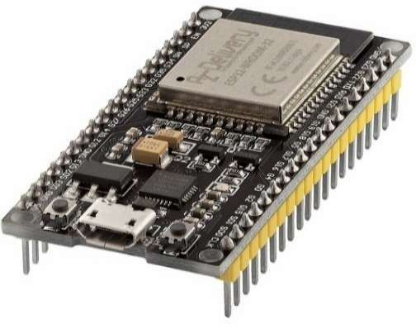
Fig:3.2: ESP32 Microcontroller

The ESP32 serves as the main controller of the IoT-based cold storage system, acting as the central processing unit that manages all sensor data, communication modules, and output devices. It is a dual-core 32-bit microcontroller with built-in Wi-Fi and Bluetooth, offering up to 18 analog channels (ADC) and multiple UART, I²C, and SPI interfaces. Its low power consumption and fast processing speed make it ideal for real-time IoT applications. In this project, the ESP32 reads data from all connected sensors, sends the collected information to the Blynk IoT server, and communicates with the GPS and GSM modules to provide location tracking and SMS alerts. It also controls the 4-channel relay module, which manages devices such as the cooling unit, fan, alarm, and light, and performs logical decision-making based on sensor inputs to maintain optimal storage conditions. The ESP32 was selected for this project because it supports multiple peripherals simultaneously while providing stable Wi-Fi connectivity and sufficient processing power for efficient real-time IoT operations, making it a reliable and versatile choice for modern cold storage supply chain management systems.

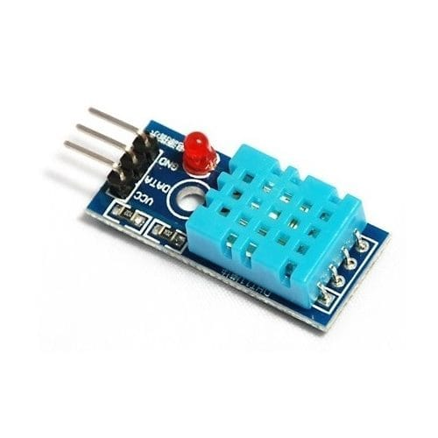
    - DHT11 Temperature and Humidity Sensor

Fig 3.3:DHT11 Temperature and Humidity Sensor

The DHT11 sensor is used in the cold storage system to measure temperature and relative humidity, providing essential data to maintain optimal conditions for perishable food items. It has a temperature range of 0–50°C and a humidity range of 20–90%, with a digital output and moderate accuracy suitable for general monitoring purposes. In this project, the DHT11 sensor helps detect overheating or excessive cooling and provides humidity data to identify excessively dry or moist conditions inside the storage. The sensor was selected because it is inexpensive, easy to interface, and reliable for general cold-chain environmental monitoring, making it an ideal choice for maintaining safe and stable storage conditions while minimizing system complexity and cost.

3.2.3 MQ135 Gas Sensor
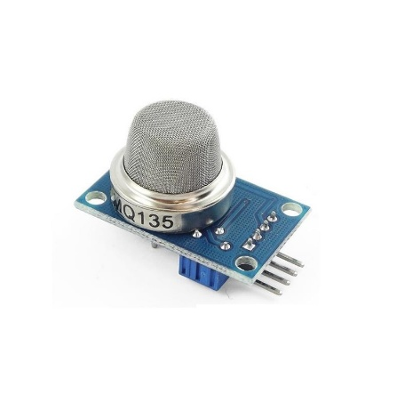
Fig 3.4: MQ135 Gas Sensor
The MQ135 gas sensor is an analog sensor used to monitor air quality inside the cold storage by detecting harmful gases such as ammonia (NH3), carbon dioxide (CO2), alcohol vapors, benzene, and other common air pollutants. In this project, the sensor helps identify early signs of food spoilage and detects the presence of unusual or hazardous gases that could affect the quality of perishable items. It provides analog values to the ESP32, which are processed to assess air quality and trigger alerts or corrective actions if required. The MQ135 was selected because it is cost-effective and capable of detecting multiple gases relevant to cold-chain contamination, making it a practical and efficient choice for maintaining safe storage conditions and ensuring food safety.

3.2.4 LDR(Light Dependent Resistor)

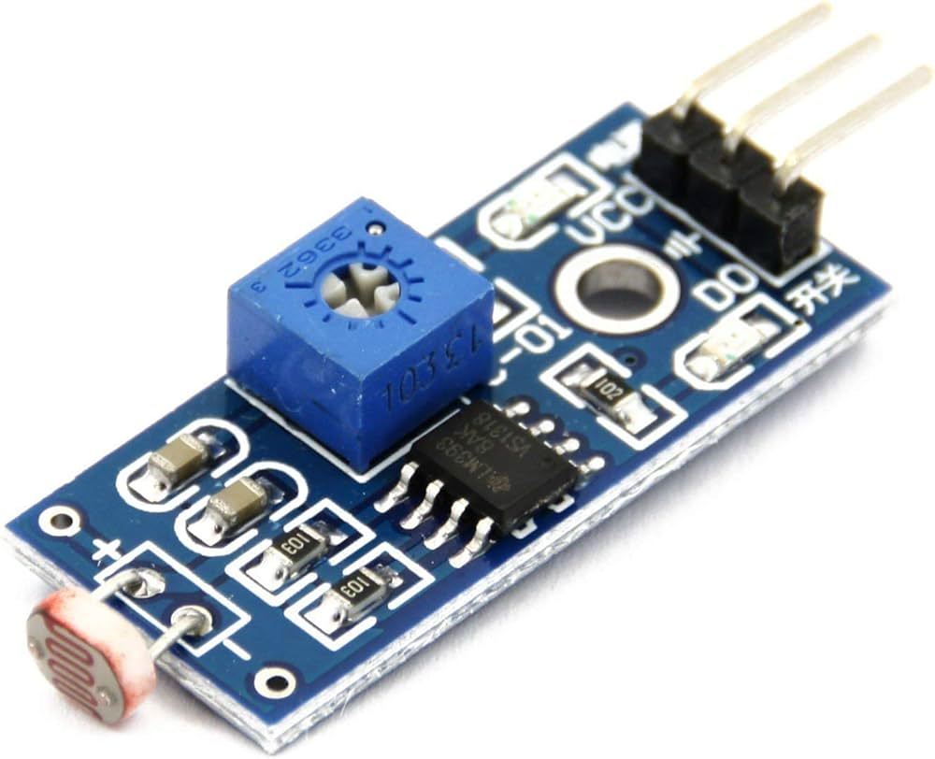
Fig 3.5: LDR

The LDR (Light Dependent Resistor) functions as a digital light sensor to detect when the cold storage door is opened or closed. When the door opens, light enters the storage area, causing the LDR to produce a LOW signal, and when the door closes, darkness results in a HIGH signal. In this project, the LDR is used to detect unauthorized door openings, trigger instant SMS alerts via the GSM module, and activate internal lighting as needed. The sensor was selected because it is simple, highly sensitive to light variations, and reliable for monitoring door status, making it an effective component for security and operational monitoring in the cold storage system.

3.2.5 Analog Moisture Sensor

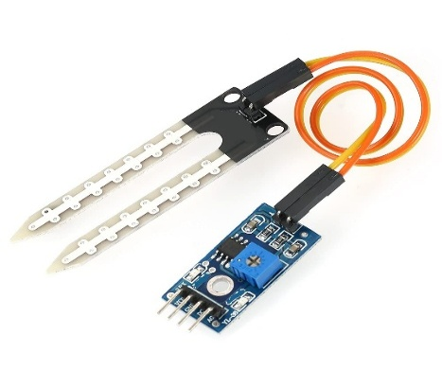

Fig:3.6: Analog Moisture Sensor

The moisture sensor is used to detect the moisture level or the presence of water and condensation inside the cold storage. High moisture levels may indicate leakage or frost formation, while low moisture can create excessively dry conditions that may affect certain food products. In this project, the sensor helps identify abnormal moisture levels and triggers alerts in case of condensation or water leakage, enabling timely corrective actions. It was selected because it provides quick and accurate monitoring of moisture, which is essential for maintaining safe storage conditions and ensuring the quality and safety of perishable items in the cold chain.

NEO-6M GPS Module
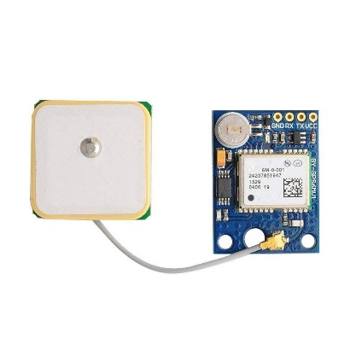
Fig 3.7: GPS Module
The GPS Neo-6M module is used for location tracking of cold chain containers or vehicles, providing precise information on latitude, longitude, and altitude. It features a high-sensitivity GPS receiver, fast signal acquisition, and UART communication for easy integration with the ESP32. In this project, the GPS module supplies coordinates whenever alerts occur, which are then sent to users via SMS through the GSM module. Additionally, it enables real-time tracking of storage units or vehicles on platforms like Google Maps, allowing operators to monitor the exact location and status of perishable goods during transportation. The module was selected because it is compact, accurate, and easily interfaces with the ESP32, making it ideal for cold chain logistics and supply chain management.

    - SIM900 / SIM900A GSM Module

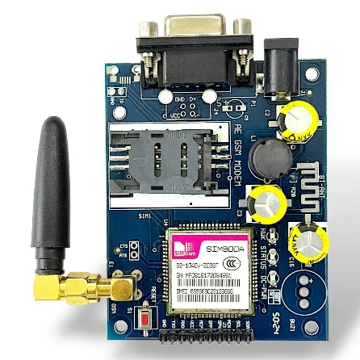

Fig 3.8: GSM Module

The GSM SIM900A module is responsible for transmitting SMS alerts in the cold storage system. It is a quad-band GSM modem that supports SMS and GPRS communication and interfaces with the ESP32 through UART using AT commands. In this project, the GSM module is used to send emergency SMS alerts whenever abnormal conditions, such as temperature rise, gas detection, or door opening, are detected. It also provides location links from the GPS module, allowing users to track the cold storage units or vehicles in real time. One of the key advantages of the GSM module is that it functions even in the absence of Wi-Fi or internet connectivity, ensuring that alerts are reliably delivered. It was selected because it is reliable, widely used in embedded systems, and provides strong network connectivity for SMS services, making it an essential component for remote monitoring and emergency notification in cold chain supply management.

    - 8 4-Channel Relay Module

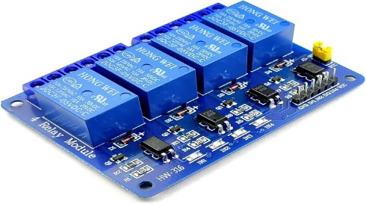

Fig 3.9: Relay Module

The 4-channel relay module is used to control cold chain appliances such as the cooling unit, alarm buzzer, fan, and internal lighting. It features optocoupler isolation, active LOW triggering, and the ability to switch both AC and DC loads. In this project, the relays receive ON/OFF commands from the ESP32 based on sensor readings or through remote control via the Blynk mobile application. This allows the system to automatically operate appliances in response to environmental conditions, such as turning on the cooling unit when temperature rises or activating the alarm during abnormal events. The relay module was selected because it provides safe electrical isolation between the low-voltage signals of the ESP32 and the high-power appliances, ensuring both operator safety and reliable operation of cold storage equipment.

3.2.9 IoT Communication Layer (Blynk Cloud + Wi-Fi)
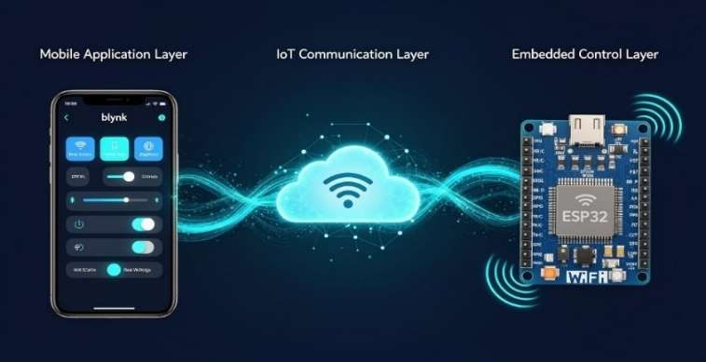
The IoT communication layer enables the robot to be controlled and monitored remotely through the Blynk cloud platform. Using the ESP32’s built-in Wi-Fi, the robot connects to the internet and exchanges real-time data with the Blynk mobile app. User commands for movement and tool activation are received through virtual pins, while sensor readings such as obstacle detection and rain levels are sent back to the dashboard. This two-way communication allows the robot to operate safely and efficiently from any remote location.

Fig 3.10: IoT Communication Layer

3.2.10 Lithium Ion Battery
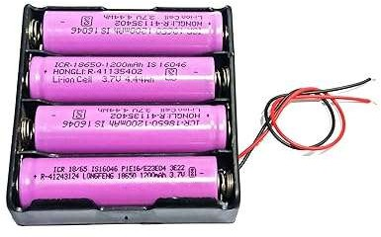
Fig 3.11: Lithium Ion Battery
The lithium-ion battery is used as the primary energy storage unit in the proposed multipurpose agricultural robot. It provides a stable and reliable DC power supply to the ESP32 microcontroller, motor driver, DC motors, servo motors, sprayer pump, and cutter motor. In this project, a 12 V lithium-ion battery pack is employed to meet the power requirements of both control electronics and high-current actuators.
Lithium-ion batteries are preferred due to their high energy density, lightweight nature, long life cycle, and low self-discharge rate. The battery can be charged using a solar panel or an external power supply, supporting sustainable and flexible operation. Proper voltage regulation is used to step down the battery voltage to levels required by the ESP32 and other low-power components.

Mechanical Design Description

3.3.1 Enclosure Structure

3.3.1.1 The system is housed in a rigid enclosure made of insulated plastic or coated metal to withstand cold and humid environments.

3.3.1.2 The enclosure protects electronic components from moisture, dust, and accidental damage.

3.3.1.3 Proper sealing is provided to prevent condensation from affecting internal circuits.

3.3.2 Sensor Mounting Arrangement

3.3.2.1 Temperature and humidity sensors are mounted at a central location inside the cold storage for accurate readings.

3.3.2.2 Gas sensors are placed near air circulation paths to detect spoilage-related gases effectively.

3.3.2.3 Moisture sensors are positioned near the floor to detect leakage or condensation.

3.3.2.4 LDR sensors are fixed near the door to detect light entry during door opening.

3.3.3 Electronics Compartment

3.3.3.1 The ESP32, relay module, GSM, and GPS modules are mounted inside a separate electronics compartment.

3.3.3.2 The compartment is isolated from high-moisture zones to ensure system reliability.

3.3.3.3 Cable routing is neatly arranged using clips and ducts to avoid loose connections.

3.3.4 Relay and Power Unit Placement

3.3.4.1 The relay module is securely mounted to control cooling units, fans, alarms, and lighting.

3.3.4.2 Power supply units are placed away from sensors to prevent electrical interference.

3.3.5 Communication Module Mounting

3.3.5.1 The GSM antenna is positioned to ensure strong network signal reception.

3.3.5.2 The GPS antenna is placed near a non-metallic surface for accurate location tracking.

3.3.5.3 All communication modules are firmly fixed to minimize vibration effects.

3.3.6 Maintenance and Accessibility

3.3.6.1 The enclosure design allows easy access for maintenance and sensor replacement.

3.3.6.2 Modular mounting ensures quick troubleshooting and upgrades.

Software Design

The software design uses the ESP32 programmed in Arduino IDE to collect and process sensor data in real time. It compares values with set thresholds, controls appliances through relays, and sends alerts via Blynk and SMS. GPS enables tracking, improving food safety and cold chain efficiency.
3.4.1 Development Environment
The software is developed using the Arduino Integrated Development Environment (Arduino IDE). The Arduino IDE is chosen due to its simplicity, wide community support, and compatibility with the ESP32 microcontroller. Embedded C/C++ programming language is used along with required libraries to interface sensors, hardwareSerial.h and other IoT platforms.
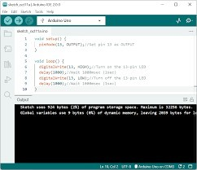
Fig 3.16: Arduino IDE Software

Libraries Used:
The following libraries are used in the software implementation:

- BlynkSimpleEsp32 – for IoT communication
- DHT.h – for temperature/humidity sensor
- TinyGPS++ – for GPS data parsing
- WiFi.h – for wireless connectivity
- HardwareSerial.h – for GSM and GPS UART

Blynk IoT Platform Integration
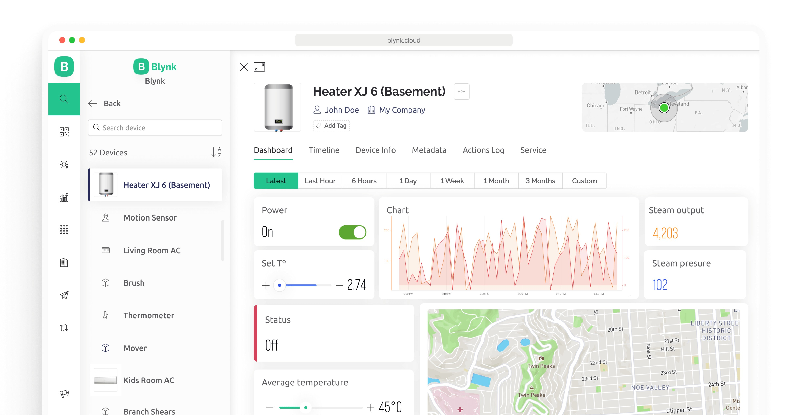
Fig 3.17: Blynk IoT Platform
The Blynk platform is used for remote monitoring and control of the cold storage . The software includes:
Functions:
- Displays sensor data
- Controls relays (ON/OFF)
- Sends notifications and logs
- Provides remote accessibility

User-friendly and ideal for IoT applications with ESP32.

Initialization Process
In the setup () function:

- Individual sensor initialize.
- Module integration initialize.
- Threshold configuration (temperature, gas, moisture)
- Door opening detection testing
- SMS alert testing with GSM
- GPS accuracy testing (indoor/outdoor)
- Blynk dashboard real-time monitoring
- Appliance control via relays

Sensor Data Processing

- Temperature & Humidity (DHT11) - Used to detect thermal variations in the cold storage.
- Gas Sensor (MQ135) - Measures air quality and detects harmful gases or spoilage indicators.
- Light Sensor (LDR) - Configured as a digital input to detect when the door is opened.
- Moisture Sensor - Monitors condensation or moisture presence, which may damage perishable products.
Each sensor is connected to ESP32 analog or digital pins, and calibration checks were done to ensure stability of readings.

3.4.6 System Integration
All hardware components were assembled according to the block diagram.
Interfacing was verified through oscilloscope and serial monitor outputs.
Special care was taken for:
- Stable power supply
- Proper grounding
- Serial communication between modules
3.4.7 Relay and Appliance Control
A 4-channel relay module was interfaced to control:
- Cooling Unit
- Alarm Buzzer
- Fan
- Light
Since the relays are active LOW, digital outputs from ESP32 are inverted to prevent accidental activation during boot.
Relays allow automated or manual control from the Blynk mobile ap

3.5 Data Flow Description

START

Initialize ESP32, WiFi,
GSM, GPS, Sensors, Relays

Read Sensor Values:
- Temperature & Humidity
- Gas Level (MQ135)
- Light/Door Status (LDR)
- Moisture Level

Send Data to Blynk
(Temp, Hum, Gas, Light,
Moisture, Relay Status)

Check Thresholds:
- Temp <20 or >30?
- Gas >2000?
- Door Open?
- Moisture High/Low?

YES (Any Condition Abnormal)

Obtain GPS Location (Latitude & Longitude)
Create Google Maps Link

Send SMS Alert to User via GSM Module
(Includes Reason + Location Link)

Activate Alarm Relay

Continue Monitoring

END

Step 1: System Initialization
The process begins by powering the ESP32 and initializing all modules:
- Wi-Fi module (for Blynk communication)
- GSM module (for SMS alerts)
- GPS module (for location data)
- DHT11, MQ135, LDR, and Moisture sensors
- 4-channel relay module
This ensures that all hardware is ready before data acquisition begins.

Step 2: Reading All Sensor Inputs
The ESP32 continuously collects real-time data:
- Temperature & Humidity from DHT11
- Gas Level (air quality) from MQ135
- Door Status (open/closed) using LDR
- Moisture Level to detect water or condensation
The readings are stored in variables and used for analysis.

Step 3: Sending Data to Blynk Cloud
All sensor readings and appliance states are uploaded to the Blynk IoT dashboard.
Users can:
- View real-time values
- Check status messages (Normal, High, Low)

Step 4: Threshold Evaluation
The ESP32 compares sensor readings with preset safe limits:
Parameter | Condition | Meaning
Temperature | <20°C or >30°C | Too cold / Too hot
Gas Value | >2000 | Poor air quality
LDR | LOW | Door open
Moisture | >3000 or <700 | High/low moisture
If any abnormal condition is detected, an alert is triggered.

Step 5: Getting GPS Location
Upon detecting an abnormal condition, the system retrieves:
- Latitude
- Longitude
A Google Maps link is generated so the user can track the exact location of the cold chain vehicle or storage container.

Step 6: Sending SMS Alerts
The GSM module sends an SMS containing:
- Type of alert (Temperature, Gas, Door, Moisture)
- Exact problem
- GPS location link
This allows the supervisor to take immediate action even without internet access.

Step 7: Activating Alarm Relay
For specific alerts (like temperature or gas), the alarm buzzer relay is activated to notify nearby personnel instantly.

Step 8: Continuous Monitoring
The system loops back and continues real-time monitoring without interruption.

CHAPTER 4
RESULTS AND ANALYSIS

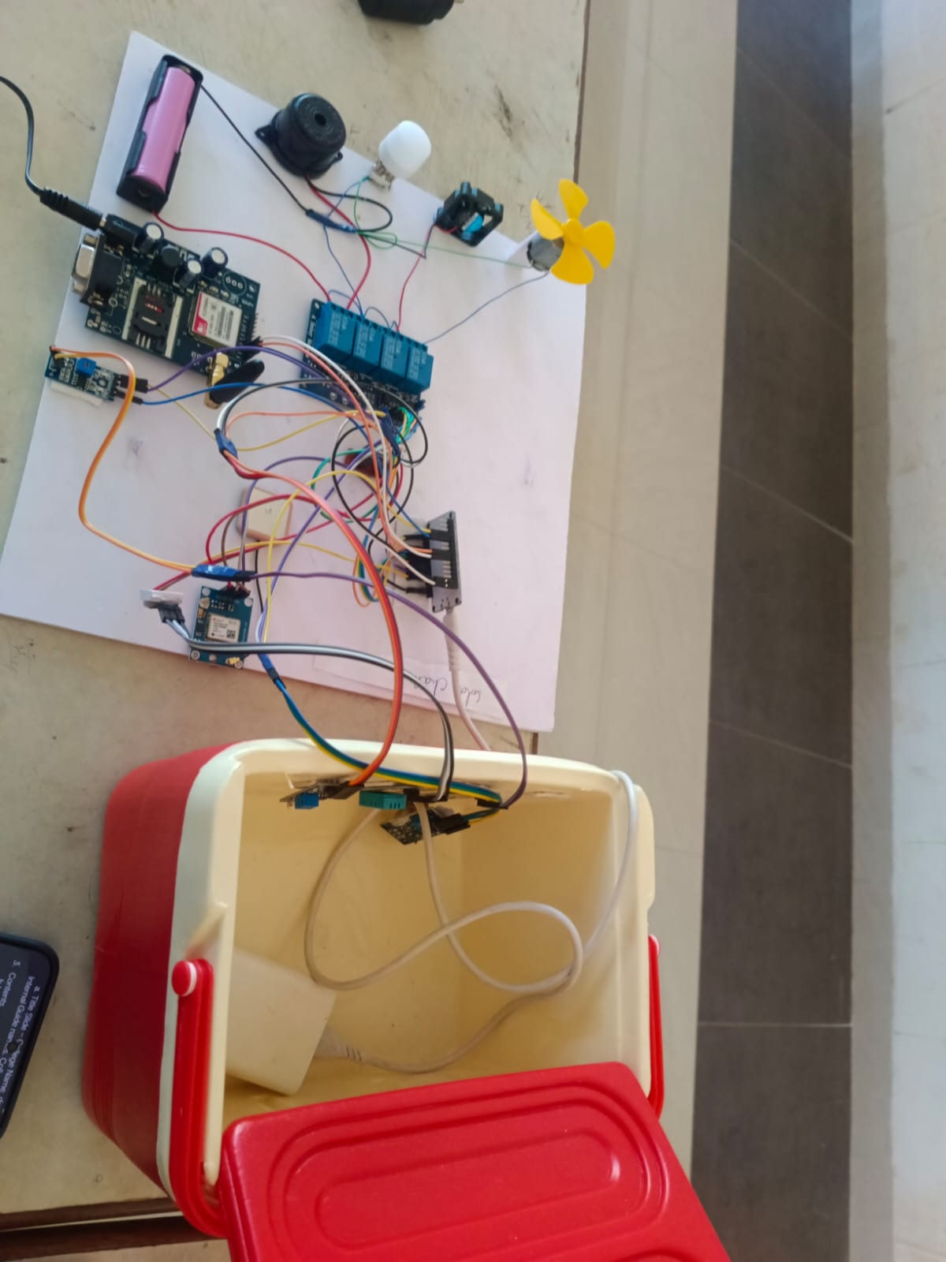

Fig 4.1:SupplyChain Management of food items in cold storage using IoT

The Cold Chain IoT Monitoring + SMS Alert + GPS Tracking System operates based on continuous environmental monitoring, real-time communication, and automated control mechanisms designed to maintain optimum conditions for temperature-sensitive goods. The system integrates IoT technology, embedded sensors, GSM communication, and GPS positioning to provide an intelligent cold-chain management solution.

4.1 Sensor Data Acquisition
The system continuously senses the environmental conditions inside the cold storage using multiple sensors connected to the ESP32 microcontroller.
a) Temperature & Humidity (DHT11)
- Measures temperature in °C and humidity in %.
- Provides digital output data every few seconds.
- The ESP32 reads this data to ensure temperature remains between 20°C and 30°C

b) Gas/Air Quality (MQ135)
- Detects harmful gases or poor air quality.
- Outputs an analog voltage proportional to the concentration of pollutants.
c) Door Status (LDR Sensor)
- Detects light to determine if the door is opened or closed.
- When the door opens, light enters → LDR value goes LOW.
- When closed → darkness → sensor gives HIGH output.

d) Moisture Sensor
- Measures moisture levels to identify frost, leakages, or dryness.
- Analog output is read by ESP32 to categorize moisture as:
  - High moisture
  - Low moisture
  - Normal
All sensor readings are processed by the ESP32 every 2 seconds using a timer function.
4.2 Data Processing and Decision Making
Once the ESP32 receives the sensor data, it analyzes it based on predefined thresholds or conditions:
Temperature Condition
- If temperature < 20°C → Too Cold
- If temperature > 30°C → Too Hot
- If abnormal, the system:
  - Sends SMS alert
  - Activates buzzer
  - Updates the Blynk dashboard
Gas Level Condition
- If gas sensor value > 2000 → Poor Air Quality
- ESP32 sends alert + buzzer ON.
Door Condition
- If door is open (LDR = LOW) → door alert sent immediately.
Moisture Condition
- If moisture too high → condensation alert
- If moisture too low → dry environment alert
Relay Control Logic
Based on data:
- Cooling Unit Relay: turns ON if temperature rises
- Fan Relay: operates to circulate air
- Buzzer Relay: activates during alerts
- Light Relay: turns ON automatically when the door is open
This decision-making ensures real-time autonomous control of cold-chain equipment.

4.3 Wireless Communication and IoT Monitoring

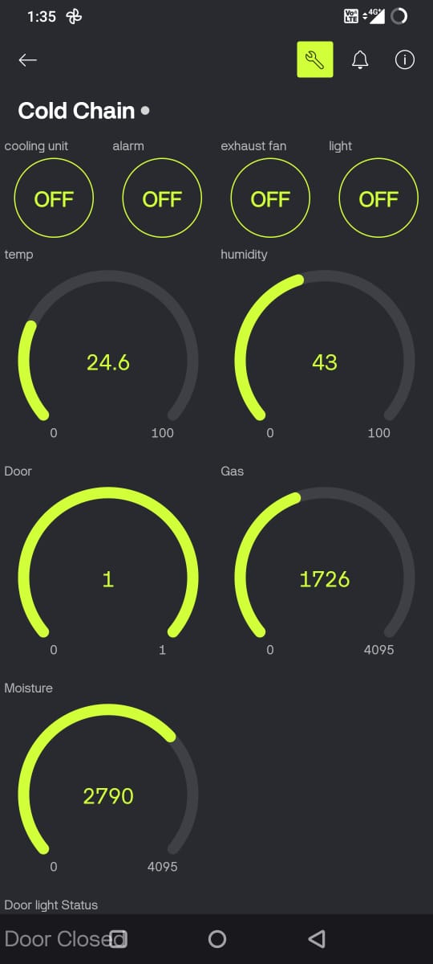

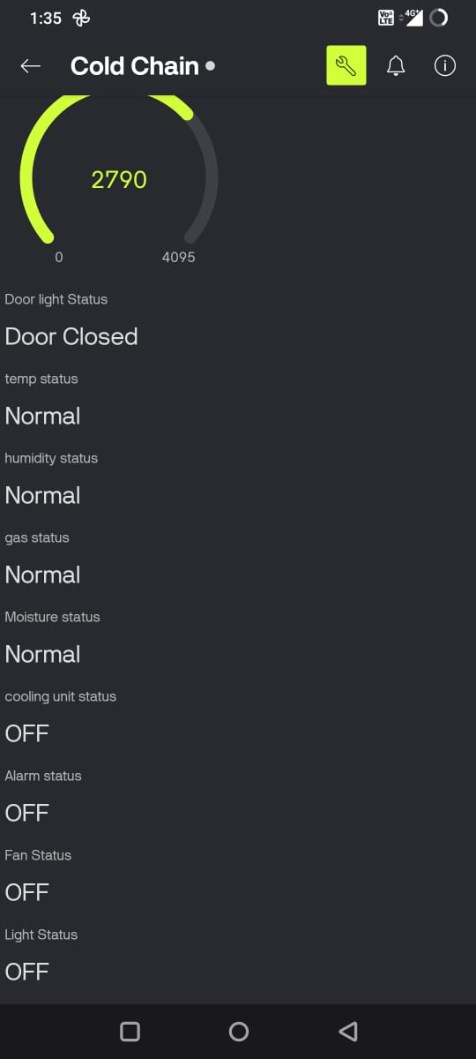
Fig 4.2:Blynk Status
a) Blynk IoT Cloud
ESP32 sends real-time sensor values to the Blynk cloud via Wi-Fi.
Users can monitor:
- Temperature
- Humidity
- Gas levels
- Moisture
- Appliance status
- Door status
Users can also control relays remotely using the Blynk mobile app.
b) Wi-Fi Connection
ESP32 connects to Wi-Fi using:
WiFi.begin(ssid, pass);
After connection, Blynk cloud communication begins automatically.

4.4 SMS Alerts via GSM (SIM900)
In critical situations, the system sends SMS alerts even if Wi-Fi is unavailable.
SMS Alert Features:
- Temperature Alerts
- Gas Alerts
- Door Open Alerts
- Moisture Alerts
- GPS Location Alerts
The SIM900 module communicates with ESP32 using AT commands:
- Set SMS mode
- Enter recipient number
- Send text
- Transmit GPS link
This ensures reliable communication under all conditions.

4.5 GPS Location Tracking
The NEO-6M GPS module continuously collects satellite data.
When an alert occurs, the system:
- Fetches latitude and longitude
- Creates a Google Maps link:
- https://maps.google.com/?q=lat,lng
- Sends this link via SMS

CHAPTER 5

CONCLUSION AND FUTURE WORK

CONCLUSION
The Cold Chain IoT Monitoring + SMS Alert + GPS Tracking System presented in this project demonstrates a reliable, efficient, and intelligent solution for monitoring temperature-sensitive goods during storage and transportation. By integrating multiple sensing, communication, and alert mechanisms, the system successfully addresses the major challenges faced in cold chain logistics—such as real-time environmental monitoring, immediate fault detection, and ensuring product integrity.
The system uses an ESP32 microcontroller as the central processing unit, interfaced with sensors like DHT11 for temperature and humidity, MQ135 for gas quality, LDR for door status, and soil moisture sensor for humidity/moisture level estimation. These sensors continuously collect environmental data and forward it to the cloud through Blynk IoT Platform, allowing users to monitor the parameters in real time from anywhere in the world.
The results obtained during testing confirm that the system performs effectively in monitoring environmental parameters, sending alerts, and updating live GPS locations. Any deviation from safe conditions immediately triggers an alert, thus minimizing product loss and improving the reliability of the cold chain process.
Overall, this project demonstrates how modern IoT technologies can be integrated to provide a low-cost, scalable, and practical cold chain management solution with real-world relevance. It highlights the potential for future enhancements using artificial intelligence, advanced sensors, better communication protocols, and renewable energy systems.
The project successfully meets its objectives and opens pathways for development in the fields of smart logistics, remote health monitoring, vaccine preservation, and food industry automation. It stands as a strong example of how IoT can revolutionize traditional monitoring systems and provide greater safety, accuracy, and efficiency in cold chain operations.

Future Work
1. Sensors continuously measure environmental parameters such as temperature, humidity, gas levels, moisture, and light inside the cold storage to ensure proper conditions for food preservation.
2. The ESP32 processes the collected data in real time and compares it with predefined safe threshold values to detect any abnormal conditions.
3. Alerts are triggered whenever sensor values exceed the set limits, indicating potential risks like overheating, spoilage, or unauthorized access.
4. GPS data is attached to alert messages, providing the exact location of the cold storage unit or transport vehicle.
5. The GSM module (SIM900) sends SMS alerts to the user, ensuring communication even when internet connectivity is unavailable.
6. Wi-Fi and the Blynk platform enable real-time monitoring of sensor data through an IoT dashboard accessible from anywhere.
7. Relays automatically control appliances such as cooling units, fans, alarms, and lights, and can also be manually operated via the Blynk app.
8. The user receives instant alerts and can take immediate corrective action to prevent food damage and losses in the cold storage supply chain.

CHAPTER 6
REFERENCES

  - Alshdadi, A., Kamel, S., Alsolami, E., Lytras, M. D., & Boubaker, S. (2024) – “An IoT Smart System for Cold Supply Chain Storage and Transportation Management.”
  - This study proposes a real‑time monitoring framework using sensors, microcontrollers, and cloud connectivity to increase visibility and decision‑making across the cold supply chain. It highlights how IoT enables tracking of temperature and environmental conditions during storage and transport.

  - Kazrin Ahmad, M. S. Islam, M. A. Jahin & M. F. Mridha (2024) – “Analysis of Internet
Implementation Barriers in the Cold Supply Chain.”This research identifies the main barriers to IoT adoption in cold supply chains using structural modeling and evaluation techniques, offering insights for overcoming implementation challenges within food logistics.

  - Natraja (2024) – AI and IoT Synergy for Intelligent Cold Chain Logistics.The paper explores how IoT sensors and AI enhance cold chain logistics for temperature‑sensitive goods by enabling real‑time condition tracking and predictive analytics to optimize routing and decision‑making.
5. “IoT Based Cold Management Chain” (2024) – IJRASET. This work proposes a cloud‑connected IoT cold supply chain system that monitors real‑time environmental parameters (temperature, humidity) to help decision support and predict shelf life, improving management of perishable goods.

6. Sathiya et al. (2024) – Tracking Perishable Foods in the Supply Chain using Chain of Things Technology. This paper examines IoT methods for ensuring visibility and data integrity in perishable food chains, emphasizing traceability and quality control throughout the supply chain.

7.If you want, I can format these references in IEEE/APA style or create a literature table (Author, Year, Objective, Contribution) for your report.

8.Kumar, S., & Patel, J., “IoT-Based Environmental Monitoring Using ESP32 and Cloud Platforms,” Journal of Emerging Technologies and Innovative Research, 2022.

9.Ojo, M., et al., “Smart Cold Chain Management: A Review,” IEEE Internet of Things Journal, vol. 8, no. 5, 2021.

10. Madhusudhan, H. R., “Real-Time Monitoring of Perishable Goods using IoT and Cloud Computing,” International Research Journal of Engineering and Technology (IRJET), 2020.

